PHASE 4
DATABASE DESIGN

Objective:
To design and configure the database required for storing user and blog information in the AI BlogNest system.

Database Technology:
MongoDB is used as the primary database, and Mongoose is used to connect the Node.js application with MongoDB.

Database Name:
BLOGNEST

Main Collections:

1. User Collection
The User collection stores the details of registered users.
Fields:
- User ID
- Name
- Email
- Password
- Role
- Created At

2. Blog Collection
The Blog collection stores the blog posts generated or created by users.
Fields:
- Blog ID
- Title
- Content
- Category
- Author
- Author Name
- Created At
- Updated At

Relationship:
One user can create multiple blog posts. Therefore, the relationship between User and Blog is one-to-many.

Database Operations:
- Insert user data
- Retrieve user data
- Store blog posts
- Retrieve blog posts
- Update blog posts
- Delete blog posts

Development Tool:
MongoDB Compass was used to view and manage the local MongoDB database during development.

Expected Output:
A properly structured MongoDB database for storing and managing user and blog information.

Phase Status:
Completed.

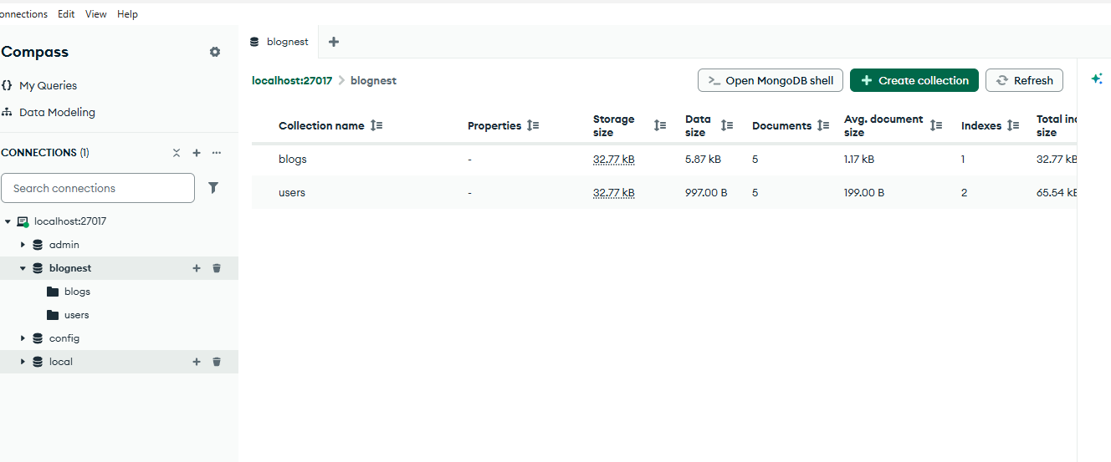
Figure 4.1: AI BlogNest MongoDB Database

